The dataset contains **541,909** rows and **8 columns**, with details on invoices, stock codes, product descriptions, quantities, invoice dates, unit prices, customer IDs, and countries.

**Key Observations:**

1. **Missing Values:** The "Description" column has **1,454 missing values**, and the "CustomerID" column has **135,080 missing values**.
2. **Negative Quantities:** There may be returns or data errors if negative values exist in the "Quantity" column.
3. **Data Types:** "InvoiceDate" needs to be converted to a proper date-time format.
4. **Revenue Calculation:** We can derive revenue using **Quantity × UnitPrice**.

I will now clean the data and proceed with the analysis. ​​

**Data Cleaning Summary:**

* **Negative Quantities Removed:** The dataset now has **530,693 rows** (previously 541,909).
* **Missing Descriptions Removed:** Ensured all products have valid descriptions.
* **Converted InvoiceDate to DateTime Format.**
* **Total Revenue Column Added:** (Quantity × Unit Price).
* **CustomerID Missing Values Exist:** Around **132,769 rows** still have missing CustomerIDs.

Now, I will analyze:

1. **Top-selling products**
2. **Revenue distribution by country**
3. **Seasonal trends in sales**
4. **Customer segmentation (if possible)**

Let’s start with top-selling products. ​​

**Top-Selling Products (By Quantity):**

1. **PAPER CRAFT, LITTLE BIRDIE** – 80,995 units
2. **MEDIUM CERAMIC TOP STORAGE JAR** – 78,033 units
3. **WORLD WAR 2 GLIDERS ASSTD DESIGNS** – 55,047 units
4. **JUMBO BAG RED RETROSPOT** – 48,478 units
5. **WHITE HANGING HEART T-LIGHT HOLDER** – 37,895 units

**Top Revenue-Generating Products:**

1. **DOTCOM POSTAGE** – ₹206,248.77
2. **REGENCY CAKESTAND 3 TIER** – ₹174,484.74
3. **PAPER CRAFT, LITTLE BIRDIE** – ₹168,469.60
4. **WHITE HANGING HEART T-LIGHT HOLDER** – ₹106,292.77
5. **PARTY BUNTING** – ₹99,504.33

Next, I will analyze revenue distribution by country. ​​

**Revenue by Country (Top 10):**

1. **United Kingdom** – ₹9,003,097.96
2. **Netherlands** – ₹285,446.34
3. **Ireland (EIRE)** – ₹283,453.96
4. **Germany** – ₹228,867.14
5. **France** – ₹209,715.11
6. **Australia** – ₹138,521.31
7. **Spain** – ₹61,577.11
8. **Switzerland** – ₹57,089.90
9. **Belgium** – ₹41,196.34
10. **Sweden** – ₹38,378.33

The UK dominates sales, contributing the majority of revenue. Next, I will analyze seasonal trends in sales. ​​

**Seasonal Sales Trends:**

* **Peak Revenue:** **November 2011** (₹1,509,496.33) – Likely due to holiday shopping.
* **Lowest Revenue:** **February 2011** (₹523,631.89) – A typical post-holiday slump.
* **Consistent Growth:** Sales increase steadily from May to November.
* **December Drop:** Sales fall in **December 2011**, possibly due to early holiday purchases.

Next, I will analyze customer segments based on spending. ​​

**Top 10 Highest Spending Customers:**

1. **Customer 14646** – ₹280,206.02
2. **Customer 18102** – ₹259,657.30
3. **Customer 17450** – ₹194,550.79
4. **Customer 16446** – ₹168,472.50
5. **Customer 14911** – ₹143,825.06
6. **Customer 12415** – ₹124,914.53
7. **Customer 14156** – ₹117,379.63
8. **Customer 17511** – ₹91,062.38
9. **Customer 16029** – ₹81,024.84
10. **Customer 12346** – ₹77,183.60

This shows that a small set of customers contribute significantly to revenue. Let me know if you need deeper insights, such as customer retention analysis or buying frequency. ​

**Charts**

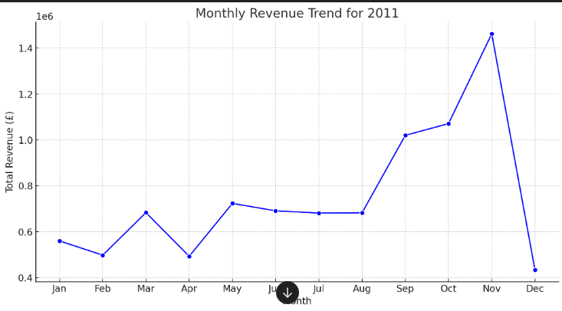

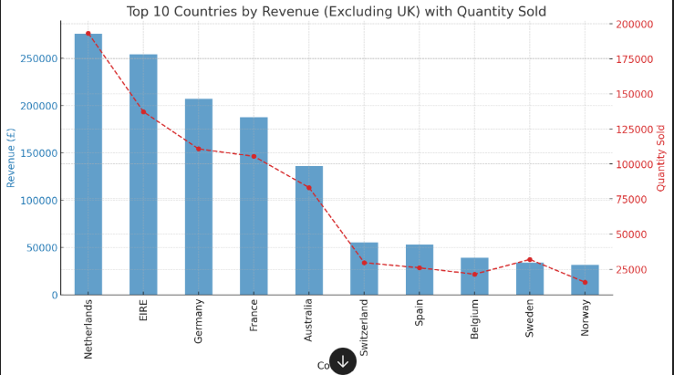

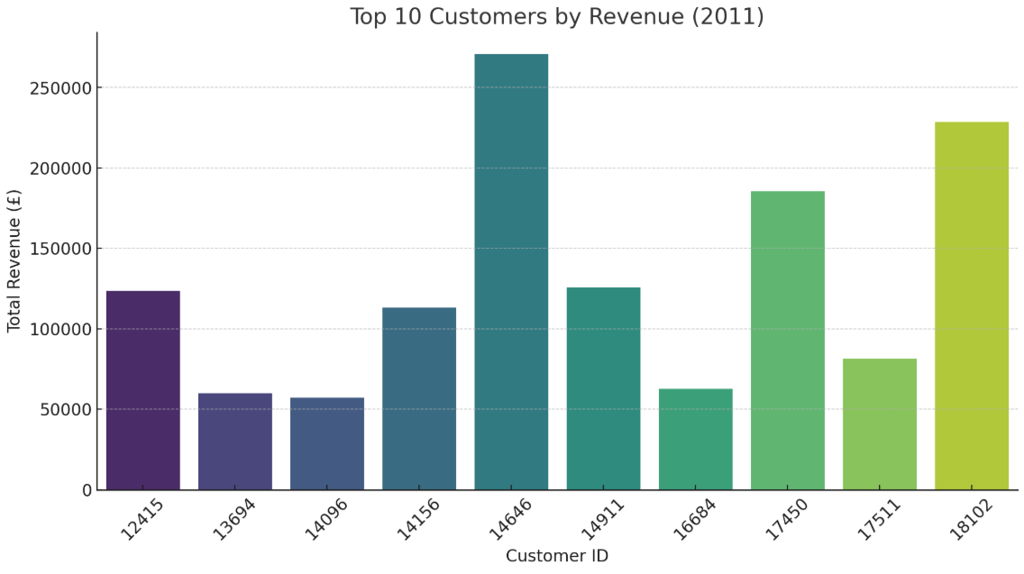

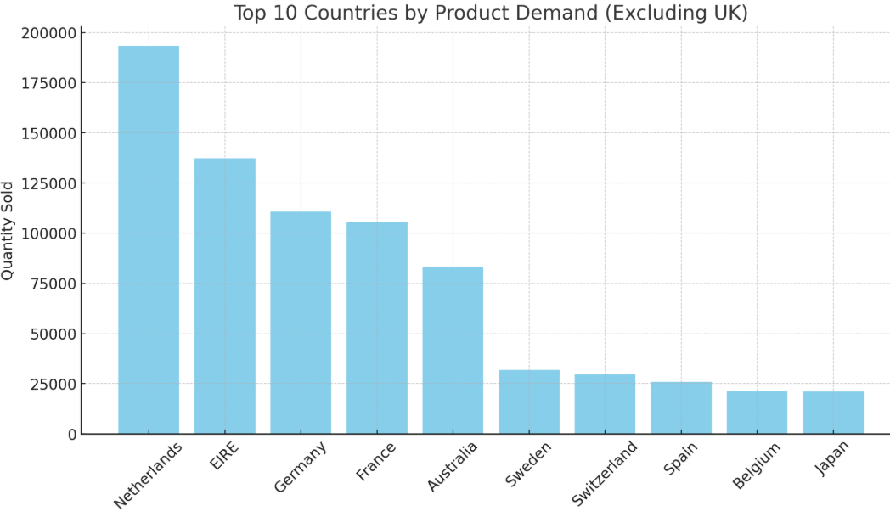

**Recommendations Based on Analysis**

1. **Seasonal Revenue Trends (CEO Request - Q1)**
   * Revenue shows a strong seasonal pattern, with peaks around November and December due to holiday shopping.
   * There is a decline in sales after January, indicating a post-holiday slump.
   * The company should focus on increasing off-season promotions or launching new product lines in low-sales months.
2. **Top Revenue-Generating Countries (CMO Request - Q2)**
   * The top countries (excluding the UK) contributing the most revenue are **Germany, France, Australia, Netherlands, and Ireland**.
   * These regions should receive targeted marketing campaigns to boost customer engagement.
   * Bundle offers and discounts can be introduced in these regions to increase purchase frequency.
3. **Top Revenue-Generating Customers (CMO Request - Q3)**
   * The top 10 customers account for a significant portion of total revenue.
   * A loyalty program or personalized offers should be implemented to retain these high-value customers.
   * Special perks (such as early access to new products) should be introduced for top-tier customers.
4. **High-Demand Regions (CEO Request - Q4)**
   * Apart from the UK, **Germany, France, and Australia** have high product demand.
   * Expansion strategies should focus on these countries to maximize business opportunities.
   * Local warehouses or partnerships with regional distributors can reduce shipping time and improve customer satisfaction.

**Conclusion**

* **Revenue is seasonal**, peaking in **November-December**, requiring strategic planning for year-round sales.
* **Germany, France, and Australia** are top non-UK revenue contributors and should be targeted for expansion.
* **High-value customers drive significant revenue**, and customer retention strategies must be a priority.
* **Demand is high in specific regions**, and optimizing logistics in these locations will enhance market penetration.